Manitoba Centre for Health Policy
Rady Faculty of Health Sciences
University of Manitoba

Health, Social and Education Outcomes of Children Participating in the Boys & Girls Clubs of Winnipeg
A Retrospective Cohort Study using Linked Administrative Data
Conducted in Partnership with the Boys & Girls Clubs of Winnipeg

December 2019

Jennifer Enns, PhD
Marni Brownell, PhD
Nathan Nickel, PhD
Dan Chateau, PhD
Alan Katz, MBChB, MSc, CCFP
Joykrishna Sarkar, MSc

Executive Summary
Out-of-school programs, which include programs offered before school, after school and during the summer, provide children and youth with a range of supervised activities designed to encourage learning and development. Depending on the particular focus of the activities, children and youth who participate in out-of-school programs tend to have improved educational achievement (such as higher school attendance and better academic performance) and improved social outcomes (such as higher social competence and fewer behavioural problems) compared to children and youth who do not participate in extra-curricular activities.
For more than 40 years, the out-of-school programs offered by the Boys & Girls Clubs of Winnipeg (BGCW) have been supporting the development of children and youth living in low-income or otherwise disadvantaged circumstances in Winnipeg. Although BGCW staff and volunteers see the positive health and social impacts of their programs on a daily basis, there has until now never been a formal evaluation of BGCW programs. In 2017, the BGCW initiated a partnership with the Manitoba Centre for Health Policy (MCHP) with the aim of linking BGCW program attendance records to the Manitoba Population Research Data Repository. This data linkage allowed researchers at MCHP to determine whether BGCW participation was associated with improvements in children and youth’s health, social and education outcomes.
Using BGCW attendance records from 2005-2016, MCHP identified a population of children and youth who had participated in BGCW programs at least once, and a comparison group of children and youth of similar age and socioeconomic status who had never participated in BGCW programs during the same time period. The study examined demographic, socioeconomic and family characteristics of these populations, and compared the following health, social and education outcomes between the two groups:
- Education: Probability of performing well on student assessments in Grade 3 (numeracy, reading) and Grade 7/8 (student engagement, mathematics, reading & writing), probability of graduating from high school
- Social: Risk of becoming involved in the justice system (being accused of a crime, witness to a crime, or victim of a crime)
- Health: Risk of teen pregnancy, risk of testing positive for a sexually transmitted infection (STI)
The study found that the vast majority of children participating in the BGCW are from low-income families, and many face other challenges in their home lives. Many children who participate in BGCW programs have mothers who started having children at a young age, or mothers who are receiving treatment for a mental illness. Many children live in families who have received services from Child and Family Services, and some have spent time in care of Child and Family Services. These findings show that BGCW have been successful in enrolling children and youth in need of their support.
Participating in BGCW programs was associated with significant improvements in Grade 3 numeracy assessments and Grade 7 student engagement assessments. The risk of becoming involved with the justice system among 12-17 year old youth declined as the frequency of their participation in BGCW programs increased, as did the risk for justice system involvement among 18-24 year old young adults who participated in BGCW programs when they were teens. The risk of female youth aged 15-19 becoming pregnant and the risk of youth aged 13-19 testing positive for a sexually transmitted infection also declined as the frequency of their participation in BGCW programs increased.
The findings of this study suggest that children and youth who participate in BGCW programs perform better in some areas of academics and are more engaged in learning than their peers. As well, participation in BGCW programs appears to be a protective factor against adverse social outcomes and risky health behaviours among youth. The findings indicate that BGCW helps to set children and youth on a positive trajectory towards success in adulthood.

Table of Contents
Executive Summary…………………………………………………………………………………………………………………… | 2
Tables and Figures……………………………………………………………………………………………………………………… | 5
Acknowledgements……………………………………………………………………………………………………………………. | 6
Introduction………………………………………………………………………………………………………………………………. | 8
Study Objectives………………………………………………………………………………………………………………………. | 10

Methods
Data Sources…………………………………………………………………………………………………………………………… | 11
Study Population………………………………………………………………………………………………………………....... | 11
Study Variables………………………………………………………………………………………………………………………. | 12
Statistical Analyses and How to Interpret the Findings…………………………………………………………… | 13

Findings & Interpretation
Who Are the Children and Youth Participating in the Clubs?………………………………………………….. | 16
Education Outcomes………………………………………………………………………………………………………………. | 20
Social Outcomes…………………………………………………………………………………………………………………….. | 30
Health Outcomes……………………………………………………………………………………………………………………. | 35
Conclusions……………………………………………………………………………………………………………………………….. | 39
References………………………………………………………………………………………………………………………………… | 40
Technical Appendices……………………………………………………………………………………………………………….. | 41

Tables and Figures
Table 1. | Characteristics of Children and Youth Participating in the BGCW | 18
Figure 1. | Number of Children and Youth Participating in BGCW Programs,  by Age | 19
Figure 2. | Number of Visits per Child or Youth to BGCW Programs, By Age | 19
Table 2. | Education Outcomes (crude percentages) | 20
Figure 3. | Probability of ‘Meeting Expectations’ in Grade 3 Numeracy | 21
Figure 4. | Probability of ‘Meeting Expectations’ in Grade 3 Reading | 22
Figure 5. | Probability of ‘Being Established’ in Grade 7 Student Engagement | 24
Figure 6. | Probability of ‘Meeting Expectations’ in Grade 7 Mathematics | 25
Figure 7. | Probability of ‘Meeting Expectations’ in Grade 8 Reading & Writing | 26
Figure 8. | Probability of Graduating from High School | 27
Figure 9. | Risk of Justice System Involvement among Youth aged 12-17 | 31
Figure 10. | Risk of Justice System Involvement among Young Adults aged 18-24 | 32
Figure 11. | Risk of Justice System Involvement among Young Adults Who Had a Prior Justice Incident as Youth | 33
Figure 12. | Risk of Teen Pregnancy Among Female Youth Aged 15-19 | 36
Figure 13. | Risk of Testing Positive for an STI among Youth Aged 13-19 | 37

Acknowledgements

The Research Advisory Committee at the Boys & Girls Clubs of Winnipeg
Many thanks to the dedicated members of the research advisory committee at the Boys & Girls Clubs of Winnipeg who lent their keen attention and expertise to this project:
- Mr. Ron Brown
- Ms. Michelle Schmidt
- Dr. John Wade
- Mr. Brent Ross
- Mr. Mirzet Alekic
- Ms. Fatima Ramjiawan
- Mr. Amir Ali

Funding Sources
Thank you to the generous funders of the Boys & Girls Clubs of Winnipeg. This research would not have been possible without their support.
- The Boys & Girls Clubs of Canada Foundation
- The Winnipeg Foundation
- United Way Winnipeg
- Private Funders of the Boys & Girls Clubs of Winnipeg
We are also grateful to the funding agencies that supported a postdoctoral fellowship and internship awarded to Dr. Jennifer Enns:
- Research Manitoba Postdoctoral Fellowship
- The Children’s Hospital Research Institute of Manitoba
- Mitacs Accelerate Postdoctoral Internship

Data Providers
We thank the following agencies and government departments for sharing their data with the Manitoba Centre for Health Policy for use in this research:
- The Boys & Girls Clubs of Winnipeg
- Manitoba Health, Seniors and Active Living
- Winnipeg Regional Health Authority
- Manitoba Education
- Manitoba Families
- Manitoba Justice
- Healthy Child Manitoba Office
All report findings and conclusions are those of the authors. No official endorsement by the data providers is intended or should be inferred.

Ethics Approvals and Data Permissions
The University of Manitoba Health Research Ethics Board (File No. HS21199) and the Government of Manitoba’s Health Information Privacy Committee (HIPC No. 2017/2018 – 32) reviewed and approved the research study.

Abbreviations
BGCW Boys & Girls Clubs of Winnipeg
CSI Community Schools Investigators
MCHP Manitoba Centre for Health Policy
PHIN Personal Health Identification Number

Introduction
The Boys & Girls Clubs of Canada provide out-of-school programs to support the healthy physical, mental, educational and social development of children and youth. They are the largest child- and youth-serving organization in Canada with over 100 Clubs across the country.¹ While their national priorities are focused on larger social issues and encouraging and empowering children and youth to be leaders, their local programs are tailored to the specific needs and characteristics of the communities in which they operate.
In Winnipeg, there are twelve Boys & Girls Clubs providing programs and services in neighbourhoods of greatest need.² The Clubs mainly serve children and youth from lower-income families, immigrant and refugee families, and other groups who are often marginalized in society. The Boys & Girls Clubs of Winnipeg (BGCW) focus on the well-being of the children and youth in their programs, providing positive role models and mentors, and teaching them the importance of healthy living, personal growth and social development. The Clubs offer programs for children and youth from kindergarten up to the age of 18 or until they graduate from high school.
The BGCW’s approach to tackling a broad range of critical issues facing young people is manifested in their five core program areas:
- Education and career exploration
- Sports and physical recreation
- Arts and cultural appreciation
- Health awareness and life-skills development
- Leadership and service to community
For more detailed information on the BGCW locations and the programs and services they offer, please visit http://www.bgcwinnipeg.ca.
The BGCW staff, volunteers and supporters know the difference participation in the Clubs can make in young people’s lives. They are safe and caring places where children and youth can play, learn and develop essential life skills. The many success stories and testimonials from people involved in the BGCW are an indication that the Clubs are helping children and youth achieve their full potential. However, in Canada, there has been very little formal research on the specific role Boys & Girls Clubs play in young people’s lives.
Out-of-school programs, like the ones offered by the Boys & Girls Clubs of Canada, encompass a wide range of focus areas and activities. The programs may offer academic support (e.g., help with homework and tutoring), mentoring and youth development (e.g., leadership training), exposure to arts and culture, and opportunities to engage in sports activities and recreation. The benefits of out-of-school programs have been widely studied in the US, and the evidence suggests that high quality programs can produce many types of improved outcomes for children and youth.³ For example, involvement in out-of-school programs has been shown to improve standardized test scores and school attendance, and reduce behavioural problems.⁴ They have also been shown to foster positive self-perceptions and social behaviours,⁵ and children and youth who attend regularly have significantly better concentration and regulation skills than those who rarely or never attend.⁶
The Boys & Girls Clubs of America have produced annual outcomes reports since 2011. Through collection of survey data from regular participants (‘regular’ meaning that they attended at least once per week in the 6-12 months before the survey), they have been able to demonstrate positive associations between participation in the Clubs and outcomes across multiple areas. For example, compared to children and youth who never or rarely attend Club activities, regular participants in the Clubs are more likely to believe that their school work is meaningful and to achieve better grades, are more likely to graduate, and are more likely to have the intention to pursue post-secondary education.⁷ Participants are also more likely to consume the daily recommended servings of fruits and vegetables, and are more likely to be physically active 5+ days per week. ⁷ As well, they are less likely to consume alcohol or smoke cannabis, and more likely to volunteer or be involved in community service. ⁷ In some jurisdictions, the individual Clubs have also been independently evaluated, providing additional insight into their positive impacts on school attendance and achievement,⁸ identity development and social skills,⁹ and family engagement in youth development.¹⁰
To date, there have been very few research studies on the impacts of Boys & Girls Clubs in Canada. A qualitative study from 2014 examined the social and emotional development of youth aged 16-18 who participated in a Club in Alberta.¹¹ The youth interviewed reflected on the ways in which their sense of self and their relationships with others changed through their involvement with the Club. To the best of our knowledge, quantitative studies on health, social or education outcomes associated with participation in Boys & Girls Clubs in Canada have not yet been conducted.
The BGCW have been operating in Winnipeg for more than 40 years, but until now, their programming had never been assessed in an empirical research study. Recognizing this unique opportunity, the BGCW partnered with the Manitoba Centre for Health Policy (MCHP) at the University of Manitoba to examine whether children and youth who participate in the BGCW have improved health, social and educational outcomes.
MCHP is home to the information-rich Manitoba Population Research Data Repository, a collection of 30+ years of administrative data on Manitobans’ interactions with the healthcare system, education system, social services, and justice system.^{12,13} It contains whole-population, de-identified person-level data for the entire province of Manitoba. The data are linkable across domains and over time using a scrambled version of each individual’s Personal Health Identification Number (PHIN) attached to each record.
Using the Repository for research allows evaluation of the real-world effectiveness of programs and services using non-intrusive data unbiased by survey sampling and recall errors, and without incurring the expense of primary data collection. It also allows examination of a broad array of outcome measures over long periods of time, producing a holistic, province-wide perspective of children’s developmental health. No other province in Canada has the same breadth and depth of population data available for research, making the partnership between the BGCW and MCHP an advantageous one in many ways.

Study Objectives
The purpose of this study was:
- To describe the sociodemographic characteristics of children and youth (age 5-18) participating in BGCW programs
- To determine whether participation in BGCW programs is associated with improved health, social and education outcomes among children and youth in Winnipeg. The outcomes of interest included:
- Education: Probability of performing well on student assessments in Grades 3 and 7/8, probability of graduating from high school
- Social: Risk of involvement with the justice system (accused of a crime, witness to a crime, victim of a crime)
- Health: Risk of teen pregnancy, risk of testing positive for a sexually transmitted infection

Methods

Data Sources
The Data Repository at the Manitoba Centre for Health Policy
This study uses data from the Manitoba Population Research Data Repository (hereafter referred to as the ‘Repository’) at MCHP. The specific Repository datasets we used in this study are listed in Appendix 1.
Data from the Boys & Girls Clubs of Winnipeg
Information on children who participated in BGCW programs was provided by the BGCW. This dataset included demographic data on participants (de-identified before being transferred to MCHP) and attendance records from 2005-2016. The dates in the attendance records represent participation in BGCW programs. They are the dates on which children and youth were recorded as having any form of contact with the Clubs. Participation could therefore include a visit made to a drop-in program or a day when a child participated in a multi-week program they had previously registered for. Detailed information on what kind of program children participated in (e.g., drop-in or enhanced program) or how long they participated (e.g., how many hours per day) was not part of this dataset.

Study Population
By linking BGCW attendance records to the data in the Repository, we first identified all children and youth who had participated in BGCW programs at least once during the study period of 2005-2016. We called this population the ‘BGCW group’.
We then identified a ‘comparison group’ of children and youth who had similar sociodemographic characteristics to the first group, but had not participated in BGCW programs during the study period. This group was matched to the BGCW group on neighborhood (5-digit postal code) and age (born within 60 days). This matching was one of the steps we took to make sure that the children and youth in the two groups would be as similar as possible, with the major difference between them being that they either did or did not participate in a BGCW program.
The final study population numbers were:
- 8,990 children and youth who participated in a BGCW program during the study period (BGCW group)
- 69,980 children and youth who had not participated in a BGCW program during the study period (comparison group)
More details about the data linkage and development of the study population can be found in Appendix 2.

Study Variables
Variables Used to Describe the Study Population
We looked at several descriptive variables to learn more about the sociodemographic characteristics of the study population, such as their biological sex, their family’s income level, and the age(s) at which they participated in the BGCW. We also looked at some other characteristics to give us additional context on the children’s home lives. These included things like how often a child’s family moved to a different residence and whether a child’s mother had a mental disorder. This information gives us an idea of what kind of challenges children in the study may have been facing in their day-to-day lives. The full list of variables is provided in Appendix 3.
Outcome Variables
We examined education outcomes, social outcomes, and health outcomes.
Education Outcomes
- Assessments among Grade 3 students for numeracy and reading
- Assessments among Grade 7 students for student engagement and mathematics
- Assessments among Grade 8 students for reading and writing
- High school graduation
Social Outcomes
- Involvement in the justice system among youth aged 12-17
- Involvement in the justice system among young adults aged 18-24 (with and without a prior justice system incident when they were youth)
Health Outcomes
- Teen pregnancy (aged 15-19)
- Positive test result for a sexually transmitted infection (STI) among youth aged 12-17
More details on the outcome variables are available in Appendix 3.

Statistical Analyses and How to Interpret the Findings
For an explanation of statistical significance, please see Appendix 4.
For simplicity’s sake, some figures and tables in this report are presented without confidence intervals or p-values. The detailed versions of these figures and tables, which include these measures of statistical significance, can be found in Appendix 5.
Statistical Models for Describing the Study Population
We tested for differences between the BGCW group and the comparison group using a generalized linear model and determined whether any of the differences between groups were significant.
Statistical Models for Assessing the Outcomes
Education Outcomes
In examining the education outcomes, we used a statistical model called a generalized additive model to generate both crude and adjusted findings. The ‘crude’ models simply compared the two study groups without any adjustments. The ‘adjusted’ models included variables to statistically adjust for known differences in study group characteristics. The adjusted models also incorporated variables to adjust for how much BGCW participation children and youth experienced. The reason for adjusting was to try to eliminate as much ‘background noise’ as possible so that if we detected differences in the outcomes, we could be more certain they were related to the amount of BGCW participation and not to some other factor.
How to interpret the findings from the Education Outcomes:
From the crude models, we determined:
- the percent of children in the BGCW group and comparison group who achieved the education outcomes;
- the difference was between the two groups, and whether this difference was statistically significant.
From the adjusted models, we calculated the probability of a child or youth achieving an education outcome based on how many times they participated in the BGCW. To determine whether boys and girls would respond differently to BGCW programs, we looked at the sexes separately. We created two types of figures to summarize the adjusted results.
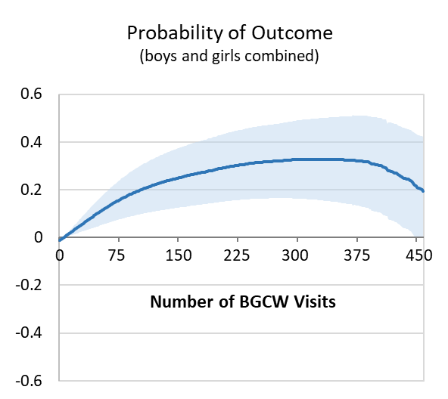
20 visits
Example Figure a.
95%
confidence
interval
The blue line graphs show how the probability of achieving an education outcome changed as the number of BGCW visits increased from left to right. The dark blue line is the probability of the outcome, and the light blue band on either side (black arrows) represents the 95% confidence interval. Where the light blue band rises completely above the horizontal 0 line, participation in BGCW was associated with improvements in that outcome. For example, in the graph to the left, we see that at roughly 20 visits (blue arrow), children attending BGCW began to experience statistically significant improvements in this outcome. By 450 visits, this association had flattened out and was no longer statistically significant.

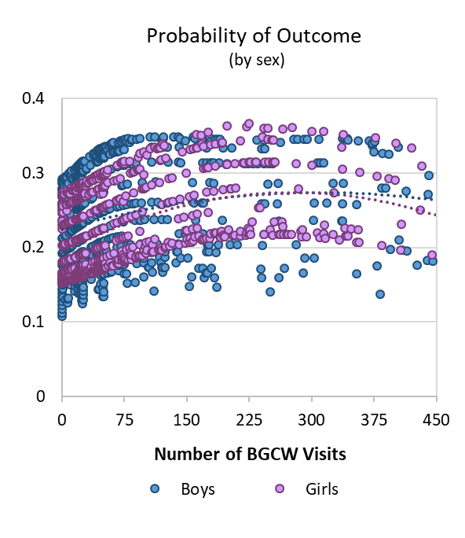
Example Figure b.
The blue and purple scatterplots show each data point (each child’s assessment result) individually, and separates the results by sex. Each dot represents a child – blue dots for boys and purple for girls. As the number of visits to BGCW increases from left to right, the probability of the outcome (shown as dotted trend lines for each sex) changes. In this example, we see that as participation increases, so too does the probability of achieving the outcome.
trend line curves upward
as participation increases

Health and Social Outcomes
For the health and social outcomes, we conducted a time-to-event analysis to determine how participation in BGCW was related to the risk of justice system involvement, teen pregnancy, or testing positive for a sexually transmitted infection (STI). This statistical model accommodated the fact that the number of visits to BGCW increased as time went by. It generated hazard ratios, or estimates of risk for the outcome, with 95% confidence intervals.
How to interpret the findings from the Health and Social Outcomes:
The results for the health and social outcomes are presented in figures like the one below:
Example Figure c.
Hazard ratios from the crude and adjusted models are represented by columns in this figure. In this example, the hazard ratio from the crude model (no adjustment) was 1.61. The confidence interval (error bar) does not cross 1.0, indicating that the hazard ratio is significant. Because the hazard ratio is greater than 1.0, it means that youth in the BGCW group had a 1.61 times higher risk of the outcome occurring than youth in the comparison group.
The adjusted model includes two important variables that adjust for (1) whether youth ever participated or never participated in BGCW (a yes/no variable), and (2) the number of BGCW visits youth made. When we adjusted for variable (1), the hazard ratio dropped from 1.61 to 1.34. The difference between the BGCW and comparison groups was smaller, but youth in the BGCW group were still significantly more likely to have the outcome occur (the confidence interval does not cross 1.0). When we also adjusted for variable (2), a more complex variable that accounts for how many times youth participated in the BGCW, the hazard ratio to dropped below 1.0. This means that as the number of visits to BGCW increased, the risk of the outcome occurring decreased. In other words, the greater the level of BGCW participation, the lower the risk of the outcome among youth in the BGCW group.

Findings & Interpretation

To view these findings with measures of statistical significance included (e.g., confidence intervals and p-values), please see Appendix 5.

Who Are the Children and Youth Participating in the Boys & Girls Clubs of Winnipeg?
The characteristics of the study population are presented in Table 1.
Looking first at the children and youth in the BGCW group, the average age at which children first participated in the BGCW was 9 years. Approximately half of the kids who participated in the BGCW were male and half were female. Most children and youth who participated in the BGCW were from lower income families, and almost 65% lived in families who had received income assistance at some point before the kids visited the BGCW.
About 44% of children in the BGCW group had a mom who was a teen when she had her first child. Forty-nine percent of children participating in the BGCW lived in families who had received services from Child and Family Services, and almost 20% of children in this group had been taken into care by Child and Family Services. About 49% of children in the BGCW group had a mom who had been diagnosed with a mental illness.
Some of these same characteristics have been measured in the larger population of Manitoba,¹⁴ and where these numbers are available, we present them in the column ‘All Manitoba’. We did not conduct statistical comparisons between the children in the study population and the All Manitoba group, but the provincial averages for these characteristics still provide context for the study findings.
Figure 1 shows that most of the children participating in the BGCW are around the age of 7-8, and there is less participation as kids get older. From Figure 2, we see that younger kids participate more intensively (visit more frequently) than older kids.
We can summarize the findings on kids participating in the BGCW as follows: The vast majority of children the BGCW serve are from low-income families, and many face other challenges in their home lives. Many participating children have mothers who started having kids at a young age, or mothers who are receiving care for a mental illness. Many children live in families who have received services from Child and Family Services, and some have spent time in care of Child and Family Services. These findings show that the BGCW have been successful in enrolling children in need of their support.
Turning now to the comparison group – we examined the same characteristics in this group as in the BGCW group to see how similar the two groups were. It was important that the study groups were similar to each other in all respects except one (BGCW participation) so when we looked at the outcomes, we could be reasonably confident that any differences we detected between the groups were because they either did or did not participate in the BGCW, and not because of some other factor.
Despite our efforts to closely match the comparison group to the BGCW group, they were not the same on all characteristics. As can be seen in Table 1, the children participating in the BGCW were worse off in some ways than their matches. For example, while 65% of families in the BGCW group received income assistance at some point before their child first participated, only 45% of the comparison group received income assistance. As well, 44% of children in the BGCW group vs. 35% of children in the comparison group had a mother who was a teen when she first gave birth. The right-most column in Table 1 indicates which characteristics were significantly different between groups.
One way to make the groups more similar is to match on more detailed characteristics. For example, we could have matched on 6-digit postal codes instead of 5-digit postal codes. But when we tried this more stringent matching method, we couldn’t find a good match for every child in the BGCW group. And since any children we couldn’t match had to be removed from the analysis, this would have reduced the size of our study population and our statistical power to detect differences between groups. So even though there were some differences between the two study groups, we decided to account for the differences between groups using another approach. Instead of additional matching, we decided to adjust for the differences between groups by adding variables from Table 1 (the ones that were different between groups) directly to the statistical models.
It may also be worth noting that we were able to match nearly all children participating in the BGCW with other children in their neighbourhoods who were of similar age and had families with similar socioeconomic characteristics but who were not participating in the BGCW. This finding presents an opportunity for further outreach efforts by the BGCW to engage other children and youth in Winnipeg who may also benefit from involvement in the BGCW.

Table 1. Characteristics of Children and Youth Participating in the Boys & Girls Clubs of Winnipeg
Characteristics | BGCW Group |  | Comparison Group |  | All Manitoba
 | Number of Kids | % of Total  or Average | Number of Kids | % of Total  or Average | % of Total  (where available) | Difference  btw Study Groups | Difference significant?
Age at First Visit to BGCW (average) | 8,990 | 9.4 | 69,980 | 9.9 |  | -0.5 | yes
Sex (%)
Male | 4,661 | 51.9 | 35,741 | 51.1 |  | 0.8 | no
Female | 4,329 | 48.2 | 34,239 | 48.9
Income Quintile (%)
Q1 (lowest) | 4,960 | 55.2 | 39,527 | 56.5 |  | -1.3 | yes
Q2 | 1,622 | 18.0 | 11,178 | 16.0 |  | 2.1 | yes
Q3 | 834 | 9.3 | 6,709 | 9.6 |  | -0.3 | no
Q4 | 703 | 7.8 | 5,444 | 7.8 |  | 0.04 | no
Q5 (highest) | 551 | 6.1 | 4,371 | 6.3 |  | -0.1 | no
Not found | 320 | 3.6 | 2,751 | 3.9 |  | -0.8 | yes
Geography (%)
Urban (Winnipeg) | 8,271 | 92.0 | 59,494 | 85.0 |  | 7.0 | yes
Rural | 719 | 8.0 | 10,486 | 15.0
Family Received Income Assistance (%) | 5,818 | 64.7 | 31,634 | 45.2 | 12-17 | 19.5 | yes
Number of Residential Moves (average) | 8,934 | 1.5 | 57,007 | 1.4 |  | 0.1 | yes
Child & Family Services Provided Services (%) | 4,394 | 48.9 | 25,280 | 36.1 | 9 | 12.8 | yes
Child was In Care of Child & Family Services (%) | 1,785 | 19.9 | 11,621 | 16.6 | 4 | 3.3 | yes
Mom’s Age at First Birth (average) | 8,835 | 21.7 | 64,088 | 22.3 |  | -0.6 | yes
Mom was a Teen at First Birth (%) | 3,929 | 43.7 | 24,778 | 35.4 | 6 | 8.3 | yes
Birth Outcomes (%)
No prenatal care before third trimester | 2,355 | 26.2 | 18,436 | 26.3 |  | -0.1 | no
Low birth weight | 338 | 3.8 | 3,109 | 4.4 |  | -0.6 | yes
Preterm birth | 486 | 5.4 | 4,089 | 5.8 |  | -0.4 | no
Mom Had at Least One Physician Visit (%)
Mood/anxiety disorder | 4,368 | 48.6 | 28,614 | 40.9 | 20 | 7.7 | yes
Psychotic disorder | 111 | 1.2 | 828 | 1.2 |  | 0.05 | no
Personality disorder | 123 | 1.4 | 942 | 1.4 |  | 0.02 | no
Mom Diagnosed with a Mental Disorder (%) | 4,386 | 48.8 | 28,740 | 41.1 |  | 7.7 | yes

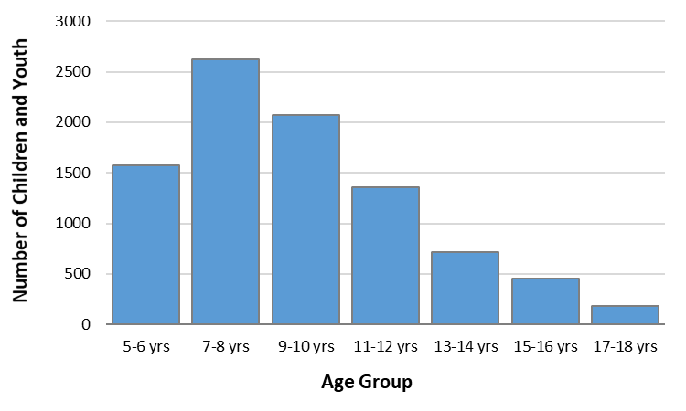
Figure 1.
Number of Children and Youth Participating in BGCW Programs,
by Age

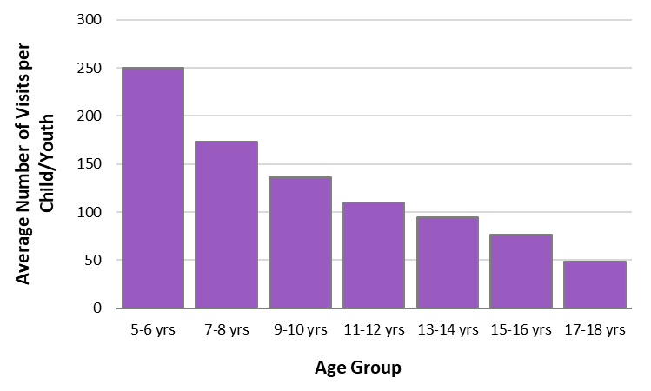

Figure 2.
Average Number of Visits per Child or Youth to BGCW Programs, by Age

Education Outcomes
Crude Outcomes
We calculated the percentage of students in the study population who did well in school assessments from Grade 3 to Grade 8, and the percentage of students who graduated high school. These percentages are ‘crude’ outcomes, having been calculated without adjusting for how much exposure the kids had to BGCW programs, or for any of the differences between the two groups presented in Table 1.
The assessments are measured in a number of ‘competencies’, which are explained more fully in the coming pages. For now, we only need to know that a student was performing well in school if they ‘met expectations’ or was ‘established’ in an assessment.
In Table 2, we see that a lower percentage of students in the BGCW group performed well in school assessment compared to the comparison group in most of the outcomes we measured. For example, 24% of Grade 8 students in the BGCW group were assessed as ‘met expectations in all 6 competencies’ for reading and writing, while 30% of Grade 8 students in the comparison group had this same assessment.

Table 2. Education Outcomes (crude percentages)
Outcome | BGCW Group | Comparison Group | Difference btw Study Groups | Significant difference?
Grade 3 Numeracy
Met expectations in 4 competencies | 22.9 | 22.7 | 0.2 | no
Grade 3 Reading
Met expectations in 3 competencies | 26.7 | 32.6 | 5.9 | yes
Grade 7 Student Engagement
Established in 5 competencies | 22.2 | 23.8 | 1.6 | yes
Grade 7 Mathematics
Met expectations in 6 competencies | 18.9 | 24.1 | 5.2 | yes
Grade 8 Reading & Writing
Met expectations in 6 competencies | 23.9 | 30.0 | 6.1 | yes
High School Graduation | 59.0 | 66.7 | 7.7 | yes

Adjusted Outcomes
We adjusted for baseline differences between the study groups by adding variables from Table 1 to the statistical models. It was also important to account for the level of participation in BGCW that children and youth experienced. In the adjusted models, we did this by incorporating the variable ‘number of BGCW visits’ into the models.
The results of the adjusted statistical models are presented as pairs of graphs for each education outcome in Figures 3-8.
Probability of ‘Meeting Expectations’ in Grade 3 Numeracy
About Grade 3 Numeracy
Students are scored on 4 competencies:
- predicts an element in a repeating pattern;
- understands that the equal symbol represents an equality of terms on either side;
- understands that a given whole number may be represented in a variety of ways (up to 100);
- uses mental math strategies to determine answers to addition and subtraction questions (up to 18).
Students may be assessed as ’meets expectations’, ‘approaching expectations’, or ‘requires ongoing help’.

Figure 3a.
Probability of 'Meeting Expectations' in Grade 3 Numeracy (boys and girls combined)
The probability of students performing well in Grade 3 numeracy increased as the number of visits to BGCW increased. The range of visits for which this relationship was significant was about 20 to 450 visits, although the association leveled off around 300 visits.
Number of BGCW Visits

Figure 3b.
Probability of 'Meeting Expectations' in Grade 3 Numeracy (by sex)
The scatterplot shows the probability of students performing well in Grade 3 numeracy with individual data points for boys vs. girls. The strong positive association between BGCW participation and meeting expectations in Grade 3 numeracy was evident for both sexes.

Probability of ‘Meeting Expectations’ in Grade 3 Reading
About Grade 3 Reading
Students are scored on 3 competencies:
- reflects on and sets reading goals predicts an element in a repeating pattern;
- uses strategies during reading to make sense of texts;
- demonstrates comprehension.
Students may be assessed as ’meets expectations’, ‘approaching expectations’, or ‘requires ongoing help’.

Figure 4a.
Probability of 'Meeting Expectations' in Grade 3 Reading (boys and girls combined)
The dark blue line indicating probability and the light blue 95% confidence interval bands fully overlap the horizontal axis, which means that there was no significant association between BGCW participation and students performing well in Grade 3 reading.

Figure 4b.
Probability of 'Meeting Expectations' in Grade 3 Reading (by sex)
Boys’ probability of meeting expectations in Grade 3 reading trended slightly upwards, while the trend for girls was initially flat and then trended slightly downwards. These two trends heading in opposite directions may to some extent ‘cancel each other out’, which could explain why the net association between BGCW participation and reading assessments for boys and girls combined is not significant. (Cont’d)
In looking at the vertical axis of Figure 4b, it is also notable that girls tended to start off at a higher probability of meeting expectations (even before any BGCW participation), whereas boys tended to start at a lower probability. There is then perhaps more ‘room for improvement’ among boys for this outcome, which may help to explain why they appeared to improve where girls (on average) did not.

Probability of ‘Being Established’ in Grade 7 Student Engagement
About Grade 7 Student Engagement
Students are scored on 5 competencies:
- demonstrates an interest in learning;
- engages in self-assessment;
- is aware of learning goals in a unit of study and/or personal learning goals;
- participates in lessons;
- accepts responsibility for assignments.
Students may be assessed as ‘established’, ‘emerging’, ‘developing’ or ‘inconsistent’.
Figure 5a.
Probability of ‘Being Established’ in Grade 7 Student Engagement (boys and girls combined)
The probability of Grade 7 students being assessed as ‘established’ in student engagement was strongly related to BGCW participation. This association was significant right from the start of a student’s participation in BGCW, reached a plateau around 320 visits, and declined only after about 600 visits.
0 100 200 300 400 500 600
Figure 5b.
Probability of ‘Being Established’ in Grade 7 Student Engagement (by sex)
Both boys and girls trended mainly upwards as the number of BGCW visits increased. Again, it is notable that girls were more likely to be assessed as ‘established’ in student engagement than boys, even before they had any contact with BGCW, although this gap between boys and girls began to shrink at higher levels of BGCW participation (around 400 to 500 visits).
Probability of ‘Meeting Expectations’ in Grade 7 Mathematics
About Grade 7 Mathematics
Students are scored on 6 competencies:
- develops mental images to represent numbers and compare them;
- makes sense of the relationships between numbers and the structure of the number system;
- understands that a given number may be represented in a variety of ways;
- represents, recognizes, constructs and extends number patterns;
- models patterns on graphs;
- writes an algebraic equation for number patterns to solve problems.
Students may be assessed as ’meets expectations’, ‘approaching expectations’, or ‘not meeting expectations’.

Figure 6a.
Probability of 'Meeting Expectations' in Grade 7 Mathematics (boys and girls combined)
The dark blue line and the light blue 95% confidence interval bands cross the horizontal axis, indicating that there is no significant relationship between meeting expectations in Grade 7 mathematics and BGCW participation at any number of BGCW visits.
0 100 200 300 400 500 600
Number of BGCW Visits

Figure 6b.
Probability of 'Meeting Expectations' in Grade 7 Mathematics (by sex)
In the scatterplot, the trend lines for boys and girls are nearly flat, indicating no relationship between BGCW participation and performing well in Grade 7 math. Girls and boys had similar probabilities of meeting expectations in Grade 7 math at any number of BGCW visits.
Probability of ‘Meeting Expectations’ in Grade 8 Reading & Writing
About Grade 8 Reading & Writing
Students are scored on 6 competencies:
- understands key ideas and messages in a variety of texts;
- can interpret a variety of texts;
- can respond critically to a variety of texts;
- generates, selects and organizes ideas to support a reader’s understanding;
- chooses language to make an impact on the reader;
- uses conventions and resources to edit and proofread to make meaning clearer.
Students may be assessed as ’meets expectations’, ‘approaching expectations’, or ‘not meeting expectations’.

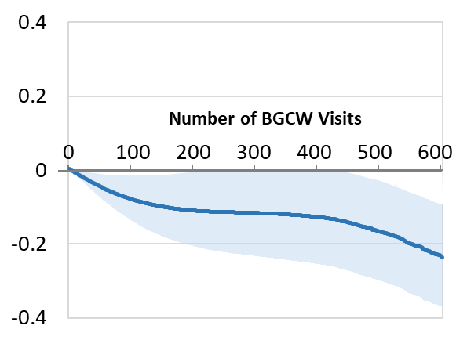
Figure 7a.
Probability of 'Meeting Expectations' in Grade 8 Reading and Writing (boys and girls combined)
The probability of meeting expectations in reading and writing in Grade 8 was, for the most part, not associated with BGCW participation. Between 50-200 visits and after about 460 visits, the dark blue line and the light blue 95% confidence interval band dip slightly below the horizontal axis, indicating a negative relationship between BGCW participation and this outcome.

Figure 7b.
Probability of 'Meeting Expectations' in Grade 8 Reading & Writing (by sex)
The probability of meeting expectations in reading and writing in Grade 8 trended downwards for both boys and girls. On average, girls had a higher probability than boys of meeting expectations in this outcome, but the probability for both declined with an increasing number of BGCW visits.

Probability of High School Graduation

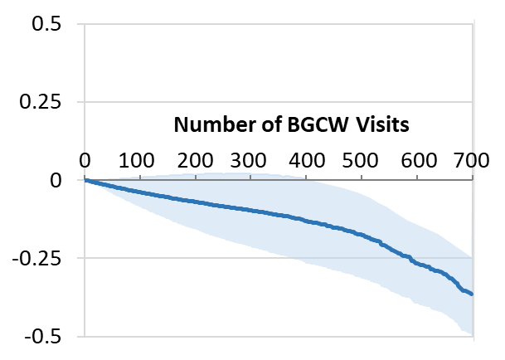
Figure 8a.
Probability of Graduating from High School (boys and girls combined)
High school graduation was largely not associated with BGCW participation. At higher numbers of visits (500+), there was a negative association between high school graduation and BGCW participation in the combined population of male and female youth.

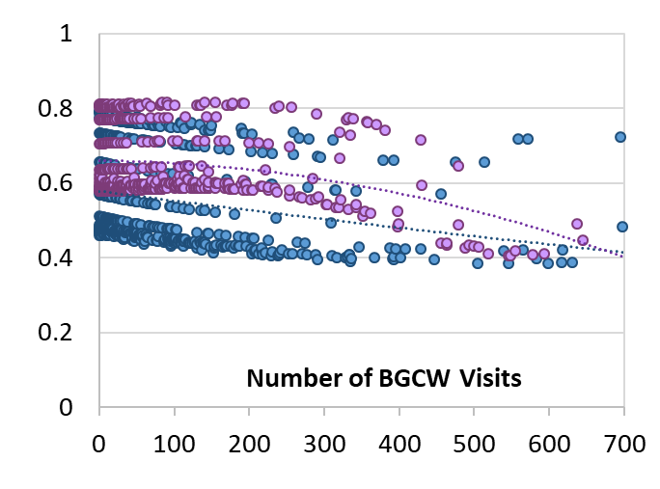
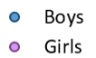
Figure 8b.
Probability of Graduating from High School (by sex)
The scatterplot shows a downwards trend in the probability of graduating high school as BGCW visits increased for both male and female youth. On average, female youth had a higher probability than male youth of graduating from high school, but the probability for both declined with an increasing number of BGCW visits.

Interpretation – Is BGCW Participation Associated with Performing Well in School?
Performing well in Grade 3 numeracy and Grade 7 student engagement was strongly and significantly associated with BGCW participation. Both outcomes were associated with BGCW participation over a large range of visits, and perhaps more notably, starting at a very low number of visits (as few as 20).
Taken together with the descriptive findings that show that the age at which children are most likely to start participating in BGCW is 7-9 years, and the age at which most children participate in the BGCW most intensively is 5-10 years, these results show that the elementary school years are a key time for intervention that is likely to help children reach their full developmental potential.
Although our data did not capture the specific BGCW programs that children participated in, the Community Schools Investigators (CSI) summer school/summer camp program for students in K-6 is one of the BGCW’s largest and most successful initiatives. One of the aims of CSI is to prevent summer learning loss by helping students maintain their math and reading skills over 5 weeks during the summer. Participation in CSI may have contributed to the positive outcome for Grade 3 numeracy.
Student engagement is a measure of how interested and engaged students are in classroom learning, projects and assignments. BGCW provides a safe space for students to engage in learning of all kinds, helps them build a positive self-image, and assists them in learning to navigate peer relationships and other social situations. The finding that participation in BGCW programs is associated with improved student engagement is an important one for many aspects of healthy development.
The remaining education outcomes were negatively associated or not associated with BGCW participation. While it is perhaps unexpected that BGCW participation would appear to be negatively associated with any education outcome, there are some possible explanations for these findings. One potential explanation is that because the majority of BGCW visits occurred among younger children, we might expect BGCW programming to have had a greater influence on younger students’ outcomes. Although many of the older children and youth in our study accumulated a large number of visits to the BGCW over several years, it’s likely that they attended BGCW programs more intensively when they were younger, and the effects of that participation may have waned over time.
Another possible reason for the null or negative associations we see could be that the specific programs children attended at a younger age were more focused on bolstering their academic skills than programs for teens. For example, academics is a core component of the CSI summer school/summer camp program for grades K-6, whereas many of the BGCW programs for teens focus on other aspects of development, such as community service, leadership and career development.
In interpreting these results, we should also take into consideration the limitations of using the available administrative data for this type of research. The data from educational assessments in Manitoba (‘meeting expectations’, ‘approaching expectations’, ‘not meeting expectations’, etc.) are very broad measures of how children are doing in school, and do not give a detailed account of children’s academic performance. There could be many factors other than what we were able to measure that impact school performance, including students’ home environments, influences from friends, and time allocated to activities outside of school (such as part-time jobs or programs offered by organizations other than the BGCW).
Even though we matched the BGCW group to the comparison group as closely as was reasonably possible, and adjusted for factors that differed between the two groups in the statistical models, there were still likely differences between the groups caused by other unmeasured or unmeasurable factors that we were unable to adjust for. There may often be part of the story that the numbers don’t capture, and these factors could contribute to the results we see.

Social Outcomes
The social outcome we investigated was youth involvement in the justice system. We used data from the Manitoba justice system to identify individuals who had been accused of a crime, a victim of a crime, or a witness to a crime. These three types of justice incidents were grouped together to create the ‘involvement in the justice system’ outcome.
Being accused of a crime included criminal offenses such as assaults or ‘break and enter’ offenses, but excluded charges for Highway Traffic Act or regulatory offenses (e.g., trespassing on school property or fishing without a license), since most people would not consider these latter offenses to be criminal offenses. We included being a victim of a crime and being a witness to a crime in this outcome (even while recognizing that they are not the same as being accused of a crime), because they reflect a similar degree of social distress or disorder in an individual’s life, and the three indicators have been shown to be highly correlated with one another.
We first examined justice involvement among youth aged 12-17. We chose this age group because children under the age of 12 cannot be charged with a criminal offence, and individuals over the age of 17 are treated as adults. This age range also corresponds well with the years youth could participate in BGCW programming, which is typically available to youth up to the age of 18 or until they graduate from high school. We also examined justice involvement among young adults aged 18-24 to determine whether previous participation in BGCW lowered the risk of justice involvement once they became young adults.
Below, we report the number and percentage of youth and young adults who were involved in a justice incident during the study period. We then present the results of the time-to-event analyses, which determined whether participation in BGCW was related to the risk of justice system involvement.
The results of the time-to-event analyses are presented as bar graphs in Figures 9-11.

Justice System Involvement among Youth aged 12-17
A total of 12.2% of the youth in the BGCW group (n=808) and 10.6% of the comparison group (n=6,269) became involved in the justice system during the study period. While it might seem surprising that a higher percentage of youth participating in the BGCW became justice-involved than youth in the comparison group, we think that this difference reflects the challenges that youth in the BGCW group faced. The fact that proportionally more BGCW participants got involved in the justice system means that the BGCW are engaging with a group of youth in need of their support.
The same pattern is evident in the crude model from the time-to-event analysis (Figure 9). The crude hazard ratio (without adjusting for any differences between groups) as 1.61. This means that youth in the BGCW group had a 1.61 times higher risk of becoming involved with the justice system than youth in the comparison group. The difference between the two groups was statistically significant.

Figure 9.
Risk of Justice System Involvement among Youth aged 12-17

We then created an adjusted model which accounted for differences between the study groups (variables from Table 1) as well as adjusting for two other variables that measured how much participation in the BGCW the youth experienced.
The first variable (1) was a yes/no variable indicating whether youth ever participated or never participated in BGCW. When we added this variable to the model, the hazard ratio dropped from 1.61 to 1.34 – i.e., the difference between the BGCW group and the comparison group became smaller, but youth in the BGCW group were still significantly more likely to become justice-involved.
However, after also adding the second variable (2) which accounted for the number of times youth participated in the BGCW, the hazard ratio fell to 0.99. Because the hazard ratio fell below 1.0, the difference became significant in the other direction. This means that the higher the number of visits to BGCW, the less likely youth in the BGCW group were to become involved with the justice system. As well, it means that with every additional 10 visits to BGCW, these youth had about a 1% lower risk of becoming involved with the justice system.
Justice System Involvement among Young Adults aged 18-24
Among young adults aged 18-24 who participated in BGCW before the age of 18, 22.5% of the BGCW group (n=744) and 14.9% of the comparison group (n=5,645) first became involved in the justice system between the ages of 18-24. This pattern is similar to what we saw in the younger age group, and in the same way, we think it reflects the higher need of supports for youth who participated in the BGCW due to their challenging home life circumstances.
Similar to the previous finding, the crude model from the time-to-event analysis generated a hazard ratio of 1.77. This indicates that (without adjusting for any differences between groups) the BGCW group was 1.77 times more likely than the comparison group to become justice-involved (Figure 10).

Figure 10.
Risk of Justice System Involvement among Young Adults aged 18-24

After adjusting for variable (1), the variable that indicated whether youth ever participated or never participated in BGCW, the hazard ratio dropped from 1.77 to 1.14. The difference between the groups in their risk of becoming involved in the justice system was therefore smaller after adjusting for the yes/no variable, but those in the BGCW group were still significantly more likely than the comparison group to become justice-involved. After also adjusting for variable (2), or the number of BGCW visits, the hazard ratio fell to 0.99. Because the hazard ratio fell below 1.0, the difference became significant in the other direction. This means that the higher the number of visits to the BGCW, the less likely young adults in the BGCW group were to become involved with the justice system. It also means that with every additional 10 visits to BGCW as a youth, these young adults had a 0.2% lower risk of becoming involved with the justice system.

Justice System Involvement among Young Adults (aged 18-24) who had a Prior Justice Incident between the ages of 12-17
Among all youth aged 18-24 who participated in BGCW before the age of 18, we selected a subset of individuals who had previously had justice system involvement (they had at least one justice incident between ages 12-17). In both the BGCW group and the comparison group, about 60% of individuals who had at least one justice incident from age 12-17 also had a justice incident from age 18-24.
The crude hazard ratio for justice system involvement between age 18-24 for this subgroup was 1.60, indicating that (without adjusting for any differences between groups) the BGCW group was 1.6 times more likely than the comparison group to become justice-involved again after the age of 18 (Figure 11).

Figure 11.
Risk of Justice System Involvement among Young Adults who had a Prior Justice Incident as Youth

After adjusting for variable (1) (ever or never participated in the BGCW), the hazard ratio dropped from 1.60 to 1.06. We see that the difference in the risk of justice system involvement between the study groups became much smaller after adjusting, so much so that youth in the BGCW group were no more likely than the comparison group to become involved in the justice system again. After also adjusting for variable (2), the number of visits to BGCW, the hazard ratio fell to 0.99. This means that the higher the number of visits to BGCW, the less likely young adults with a prior incident were to become involved in the justice system. Stated another way, with every additional 10 visits to BGCW as a youth, these young adults had a 0.1% lower risk of becoming involved with the justice system, even if they had been involved before.

Interpretation – Is BGCW Participation Associated with Lower Risk of Justice System Involvement?
The broadly defined outcome of ‘justice system involvement’ was the key social outcome we examined in this study. This variable includes three different aspects of justice system involvement: being accused of a crime, being a victim of a crime, and being a witness to a crime. Admittedly, these are very different ways of being in contact with the justice system, but other research studies using the variables separately have found that there is a high degree of correlation between them. In any case, any type of justice system involvement is reflective of social distress and need for intervention.
As discussed above, the results of the crude models from the time-to-event analysis of risk of justice system involvement are initially somewhat counterintuitive – how do we explain why youth participating in BGCW programs appear to be significantly more likely than youth not participating to become justice-involved? This likely reflects the aim of BGCW to be a resource for troubled youth facing numerous home life challenges (possibly including behavioural problems, mental illness, and other family challenges) that are a risk to their social well-being. The fact that youth participating in BGCW are at higher risk of justice system involvement than the comparison group speaks to the Clubs’ success in engaging those individuals in programs that can help steer them into a more positive trajectory.
In the results from the adjusted models, we see that as we account for (adjust for) participation in BGCW programs, first using a simple dichotomous variable (yes/no BGCW participation) and then the more complex ‘number of BGCW visits’ variable to measure more precisely what ‘dose’ of BGCW each youth received, there is a significant shift in the findings. Even though youth in the BGCW group face more challenges and are more likely to become justice-involved than youth in the comparison group, BGCW participation acts as a protective factor and lowers the risk of justice incidents occurring for these youth.
This relationship is evident not only among teens (12-17 years), but also among young adults aged 18-24 who are no longer participating in BGCW programs, and also among 18-24 year olds who had a justice incident when they were younger. This last finding is particularly notable, since repeat offenses are very common among youth who become justice-involved at a young age.

Health Outcomes
The two key public health outcomes we chose to examine in this study were teen pregnancy among 15-19 year old female youth, and testing positive for a sexually transmitted infection (STI) among 13-19 year old youth (male and female). For the teen pregnancy outcome, we included all pregnancies that occurred during the study period, including those that did not result in a birth. Multiple pregnancies to a single individual were counted as separate events. For the STI outcome, we counted all positive tests for syphilis, chlamydia and gonorrhea. If an individual tested positive for any STI more than once, these were counted as separate events.
We first calculated the number and percentage of youth who had these outcomes occur during the study period. We then conducted time-to-event analyses to determine whether participation in BGCW was related to the risk of becoming pregnant or testing positive for an STI. The time-to-event analysis accommodates the fact that the number of visits to BGCW may increase as time goes by, and measures the risk of the outcome occurring as the number of visits increases.
The results of these analyses are presented as bar graphs in Figures 12-13.

Teen Pregnancy
A total of 13.1% of the female youth aged 15-19 in the BGCW group (n=373) and 11.5% of the female youth aged 15-19 in the comparison group (n=3,168) became pregnant during the study period. This pattern of a higher proportion of youth in the BGCW group youth having an outcome than the youth in the comparison group will be familiar from the previous section on social outcomes. It’s likely that this difference in teen pregnancies reflects the challenges that youth in the BGCW group faced. The fact that proportionally more BGCW participants became pregnant as teens means that the BGCW are engaging with the youth most in need of their support.
The crude model from the time-to-event analysis generated a hazard ratio of 1.77 for teen pregnancy (Figure 12). This means that (without adjusting for any differences between groups) female youth in the BGCW group had a 1.77 times higher risk of a teen pregnancy than female youth in the comparison group. The difference between the two groups was statistically significant.

Figure 12.
Risk of Teen Pregnancy among Female Youth aged 15-19

The adjusted model accounted for differences between the study groups (variables from Table 1) as well as adjusting for two other variables that measured how much participation in the BGCW the youth experienced. After adjusting for variable (1), a yes/no variable indicating whether youth ever participated or never participated in BGCW, the hazard ratio dropped from 1.77 to 1.48. The difference between the groups became smaller, but youth in the BGCW group were still significantly more likely to have a teen pregnancy. However, after also adjusting for variable (2), a variable that accounts for the number of times youth participated in the BGCW, the hazard ratio fell to 0.98. Because the hazard ratio fell below 1.0, the difference became significant in the other direction. This means that the higher the number of visits to BGCW, the less likely youth in the BGCW group were to have a teen pregnancy. It also means that with every additional 10 visits to the BGCW, these youth had a 1.3% lower risk of a teen pregnancy.
Testing Positive for an STI
A total of 23.2% of youth aged 13-19 in the BGCW group (n=1,410) and 19.0% of youth aged 13-19 in the comparison group (n=10,705) tested positive for syphilis, chlamydia or gonorrhea during the study period.
The crude model from the time-to-event analysis generated a hazard ratio of 1.79 for testing positive for an STI (Figure 13). This means that (without adjusting for differences between groups) youth in the BGCW group had a 1.79 times higher risk of testing positive for an STI than youth in the comparison group. The difference between the two groups was statistically significant.

Figure 13.
Risk of Testing Positive for a Sexually Transmitted Infection among Youth aged 13-19

The adjusted model accounted for differences between the study groups (variables from Table 1) as well as adjusting for the two other variables that measured how much participation in the BGCW the youth experienced. After adjusting for variable (1), a yes/no variable indicating whether youth ever participated or never participated in BGCW, the hazard ratio dropped from 1.79 to 1.54. The difference between the groups became smaller, but youth in the BGCW group were still significantly more likely to test positive for an STI. However, after also adjusting for variable (2), a variable that accounts for the number of times youth participated in the BGCW, the hazard ratio fell to 0.99. Because the hazard ratio fell below 1.0, the difference became significant in the other direction. This means that the higher the number of visits to BGCW, the less likely youth in the BGCW group were to test positive for an STI. It also means that with every additional 10 visits to the BGCW, these youth had a 0.4% lower risk of testing positive for an STI.

Interpretation – Is BGCW Participation Associated with Lower Risk of Poor Health Outcomes?
We examined two key public health outcomes among the youth in the study population.
The risk of having a teen pregnancy was assessed among female youth aged 15-19. In this outcome, we included all pregnancies identified in the Data Repository, including those not resulting in a live birth. Thus, the outcome really serves as a measure of whether or not teens engaging in sexual activity used effective contraceptive methods. At the same time, we recognize that a pregnancy may not as disruptive to a teen’s academic performance or advancement as a live birth would be. Many of the pregnancies we included in this study did not result in a live birth.
Classifying a teen pregnancy as a ‘poor health outcome’ may be contentious for some people. In some communities, motherhood is highly desired and childbearing often begins in the teenage years, bringing increased responsibilities, social recognition and a sense of purpose for young mothers. But despite these positive aspects, there are many challenges to teen motherhood. There is good evidence showing that teen pregnancy and birth can interrupt the mother’s schooling and career plans, setting up a cycle of disadvantage for the child. The children of teen mothers are also documented as having poorer outcomes on average than children born to older mothers. Children of teen mothers tend to have more health problems, perform more poorly in school, and are more likely to have lower earnings as an adult. It is from this perspective that we considered it important to assess teen pregnancy as an adverse public health outcome for youth.
Testing positive for an STI is another important public health indicator of potentially high-risk sexual behaviour. We included three common STIs (syphilis, chlamydia and gonorrhea) in our analysis.
The results for the health outcomes followed a similar pattern to those for the justice system outcomes. The crude hazard ratios indicated that youth in the BGCW group were significantly more likely than the comparison group to engage in potentially high-risk health behaviours. This could be explained by the BGCW’s focus on providing support to youth struggling to manage the many challenges they face at home, in school, and in their peer groups. Notably, findings from the adjusted models indicated that teen pregnancy and testing positive for an STI became less likely as participation in BGCW programs increased.

Conclusions
Through participation in the Boys & Girls Clubs of Winnipeg, children and youth living in difficult socioeconomic circumstances and facing multiple challenges in their home lives have access to a safe and supportive environment in which to experience new opportunities, overcome barriers, and build positive relationships. This study of the association between Boys & Girls Clubs of Winnipeg participation and the health, social and education outcomes of children and youth in Winnipeg provides convincing evidence for benefits to participating in the Clubs’ out-of-school activities. Participating in the Boys & Girls Clubs of Winnipeg was associated with improvements in key education outcomes and a reduction in the risk of adverse health and social outcomes.
The importance of providing supports for children at a young age cannot be overstated. Programs like those offered by the Boys & Girls Clubs of Winnipeg can have long-lasting impacts on health and well-being. Agencies like the Boys & Girls Clubs of Winnipeg influence health and well-being across the life course and support the growth and development of children and youth in our province, and these are essential qualities for building a vibrant, successful society.¹⁵
The Boys & Girls Clubs of Winnipeg should be commended for seeking out opportunities to have their programs empirically evaluated. From the start of this study, their aim has been to discover ‘what works’ to improve the lives of their participants and do more of that, while at the same time seeking to improve areas that need attention. Rigorously evaluating programs and policies designed to shape the developmental trajectories of children and youth provides high quality evidence to program stakeholders and policymakers. This evidence in turn allows them to make informed decisions about how to enhance existing programs to better serve the community’s needs, and to ensure that taxpayer dollars are supporting proven strategies for improving the health and well-being of Manitobans.

References
1. Boys & Girls Clubs of Canada. Boys & Girls Clubs of Canada 2018 Annual Report. Ottawa, ON; 2018. https://www.bgccan.com/en/who-we-are/annual-report/.
2. Boys & Girls Clubs of Winnipeg. Boys & Girls Clubs of Winnipeg 2018 Annual Report. Winnipeg, MB; 2018. http://www.bgcwinnipeg.ca/about/publications-and-resources.
3. Durlak JA, Weissberg RP. The Impact of After-School Programs That Promote Personal and Social Skills. Chicago, IL: Collaborative for Academic, Social, and Emotional Learning; 2007.
4. Shernoff DJ. Engagement in after-school programs as a predictor of social competence and academic performance. Am J Community Psychol. 2010;45(3-4):325-337.
5. Durlak J, Weissberg R, Pachan M. A meta-analysis of after-school programs that seek to promote personal and social skills in children and adolescents. Am J Community Psychol. 2010;45(3-4):294-309.
6. Riggs N, Bohnert A, Guzman M, Davidson D. Examining the potential of community-based after-school programs for Latino youth. Am J Community Psychol. 2010;45:417-429.
7. Boys & Girls Clubs of America. Measuring the Impact of Boys & Girls Clubs: 2018 National Outcomes Report. Atlanta, GA; 2018. https://issuu.com/bgca/docs/2018_national_youth_outcomes_report.
8. Springer K, Diffily D. The relationship between intensity and breadth of after-school program partiicpation and academic achievement: evidence from a short-term longitudinal study. J Community Psychol. 2012;40(7):786-798.
9. Sheltzer JM, Consoli AJ. Understanding the impact of an after-school music program with engaged underserved youth. J Community Psychol. 2019;47(6):1364-1379. doi:10.1002/jcop.22193
10. Kreider H, Raghupathy S. Engaging Families in Boys & Girls Clubs: An Evaluation of the Family PLUS Pilot Initiative. Sch Community J. 2010;20(2):9-21.
11. Haberlin M. Finding their voice: Youth’s perspectives on their participation at the Boys and Girls Clubs of Canada. 2014.
12. Roos LL, Nicol JP. A research registry: uses, development, and accuracy. J Clin Epidemiol. 1999;52(0895-4356 (Print)):39-47.
13. Roos LL, Gupta S, Soodeen R, Jebamani L. Data quality in an information-rich environment: Canada as an example. Can J Aging. 2005;24(Suppl 1):153-170.
14. Brownell M, Chartier M, Santos R, et al. How Are Manitoba’s Children Doing? Winnipeg, MB: Manitoba Centre for Health Policy; 2012.
15. Hertzman C, Power C. A life course approach to health and human development. In: Heymann J, Hertzman C, Barer ML, Evans RG, eds. Healthier Societies: From Analysis to Action. Oxford: Oxford University Press; 2006.

Technical Appendices
Appendix 1. Datasets from the MCHP Repository Used in This Study

Manitoba Health Insurance Registry | Demographic information from the time an individual is registered as a resident of Manitoba, including age, sex and area of residence
Public Use Canada Census Files | Information on the average small area-level household income, which we used to construct income quintiles and measure socioeconomic status
PATHS Data Resource | A dataset containing information on the health, socioeconomic status, social services use and education assessments of children born 1984-2016 who lived in Manitoba at some point during their childhood
BabyFirst Screen and Families First Screen | Universal survey administered at birth, collects measures of biological, social, and family risk factors
Healthy Baby Prenatal Benefit | Measures of biological, social, and family risk factors from expectant mothers
Social Assistance Management Information Network | Individual-level information on receipt of income assistance
Child and Family Services | Information on families receiving services from Child and Family Services and families whose children had been taken into care
Medical Claims/Medical Services | Records of ambulatory physician visits and reasons for visits
Enrollment, Marks and Assessments | Manitoba Education records on school enrollment, grade repetition, and high school graduation; literacy, numeracy and student engagement assessments
Prosecution Information and Scheduling Management | Information from Manitoba Justice on individuals who have ever been witness to a crime, accused of a crime, or a victim of a crime
Hospital Discharge Abstracts | Reasons for hospitalizations, including births
Cadham Provincial Laboratory | Laboratory test results, e.g., for sexually transmitted infections

Appendix 2. Developing the Study Population
To develop the study population, we started by identifying records from all children born 1987-2010 who lived in Manitoba at some point during their school years (kindergarten to grade 12). These children were the appropriate age to have participated in BGCW programs during the years for which we had BGCW program data (2005-2016).
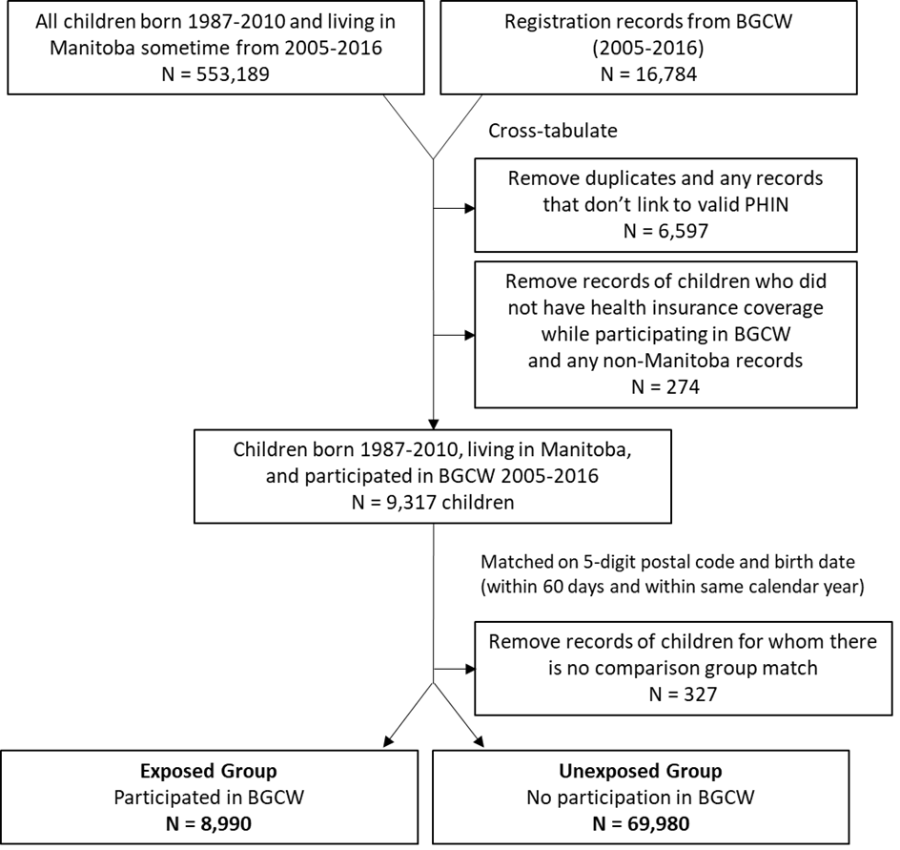
In the Repository, we identified 533,189 children born 1987-2010 and living in Manitoba at some time during the 2005-2016 time period. In the BGCW program data, we identified 16,784 children who participated in a BGCW program at least once during the 2005-2016 time period. We cross-tabulated these two datasets, removing any records that were duplicates (e.g., records that were for the same child registered under different name variations), any records that did not link to a valid PHIN, and any records where the child was not covered by Manitoba health insurance while participating in BGCW programs. After applying these criteria, we had a group of 9,317 children who had participated in BGCW programs (2005-2016) and for whom we had Manitoba health insurance records for at least part of that time.
We then developed a comparison group of children who had similar socio-demographic characteristics to the first group, but had not participated in BGCW programs during the study period. We matched each of the 9,317 participating children to other children who lived in the same 5-digit postal code and were the same age (born within ±60 days and also in the same calendar year or school year). We removed records for children for whom no match was available.

This resulted in the following numbers for the final study cohort:
- 8,990 children who participated in a BGCW program during the study period (BGCW or exposed group)
- 69,980 children who had not participated in a BGCW program during the study period (comparison or unexposed group)
Appendix 3. Study Variables
Descriptive Variables
We measured the following sociodemographic, family and other contextual characteristics of the children and youth in the study population:
Sex | Each child’s biological sex (male/female) is recorded in the Manitoba Population Health Registry.
Child’s age at first enrollment in BGCW | A child’s age when they first participated in a BGCW program.
Income Quintile | Income quintiles were calculated using small geographical area information (based on postal codes) from the Canada Census. The average incomes for each postal code in Winnipeg were sorted from lowest to highest, and then was divided into 5 roughly equal groups (5 quintiles). The individuals in the study cohort were assigned a quintile based on their own household income. Q1 represents people with the lowest incomes and Q5 represents people with the highest incomes. About 3-4% of the population were excluded from this analysis because their postal code was not available.
Family received income assistance | The child’s mother received income assistance at any point between the child’s birth and the date the child first participated in BGCW
Number of residential moves | Number of times the child’s family moved to a different residence in the 5 years before child first participated in BGCW
Family received services from Child and Family Services | The child’s family received support services from Child Protection Services in the 5 years before the child first participated in BGCW
Child was taken into care of Child and Family Services | The child was taken into care of Child Protection Services for at least one day before they first participated in BGCW
Mom’s age at first birth | Mom’s age when she gave birth to her first child
Teen at first birth | Mom was 19 years old or younger when she first gave birth
No prenatal care before third trimester | Mom had no prenatal physician visits until third trimester
Low birth weight | Baby’s birth weight was less than 2,500 g
Preterm birth | Baby was born before 37 weeks gestation
At least one physician visit for a mood/anxiety disorder | Mom had at least one physician visit for a mood/anxiety disorder in the 5 years before child first participated in BGCW
At least one physician visit for a psychotic disorder | Mom had at least one physician visit for a personality disorder in the 5 years before child first participated in BGCW
At least one physician visit for a personality disorder | Mom had at least one physician visit for a personality disorder in the 5 years before child first participated in BGCW
Any mental disorder | Mom had a mental disorder diagnosis (any of mood/anxiety/psychotic/personality) in the 5 years before child first participated in BGCW

Outcome Variables
The definitions of the study’s outcome variables are as follows:
Grade 3 Numeracy  Meets expectations  Approaching expectations  Requires ongoing help | For Grade 3 numeracy, a student is scored on 4 competencies: i) predicts an element in a repeating pattern; ii) understands that the equal symbol represents an equality of terms on either side; iii) understands that a given whole number may be represented in a variety of ways (up to 100); iv) uses mental math strategies to determine answers to addition and subtraction questions (up to 18).
Grade 3 Reading  Meets expectations  Approaching expectations  Requires ongoing help | For Grade 3 reading, a student is scored on 3 competencies: i) reflects on and sets reading goals; ii) uses strategies during reading to make sense of texts; iii) demonstrates comprehension.
Grade 7 Student Engagement  Established  Emerging  Developing  Inconsistent | For Grade 7 student engagement, a student is scored on 5 competencies: i) demonstrates an interest in learning; ii) engages in self-assessment; iii) is aware of learning goals in a unit of study and/or personal learning goals; iv) participates in lessons; v) accepts responsibility for assignments.
Grade 7 Mathematics  Meets expectations  Approaching expectations  Not meeting expectations | For Grade 7 mathematics, a student is scored on 6 competencies: i) develops mental images to represent numbers and compare them; ii) makes sense of the relationships between numbers and the structure of the number system; iii) understands that a given number may be represented in a variety of ways; iv) represents, recognizes, constructs and extends number patterns; v) models patterns on graphs; vi) writes an algebraic equation for number patterns to solve problems.
Grade 7/8 Reading & Writing  Meets expectations  Approaching expectations  Not meeting expectations | For Grade 7/8 reading and writing, a student is scored on 6 competencies: i) understands key ideas and messages in a variety of texts; ii) can interpret a variety of texts; iii) can respond critically to a variety of texts; iv) generates, selects and organizes ideas to support a reader’s understanding; v) chooses language to make an impact on the reader; vi) uses conventions and resources to edit and proofread to make meaning clearer.
High School Graduation | Completed high school within two years of expected graduation year, based on birth year
Justice System Involvement | Recorded in the Manitoba Justice data as being accused of a crime, a witness to a crime, or a victim of a crime
Teen Pregnancy | All pregnancies among female study population youth aged 15-19, including those not resulting in a live birth
Positive Test for STI | At least one positive laboratory test for syphilis, chlamydia and gonorrhea among 13-19 year old youth.

Appendix 4. Statistical Analyses
What is a significant difference?
A significant difference is one where we are relatively sure the difference between two groups is not due to random chance. The confidence interval and p-value tell us how confident we should be in our belief that the difference is real or that the difference is simply due to chance. When we calculate the difference between two values, a confidence interval that does not cross zero or a p-value of less than 0.05 (p<0.05) indicates statistical significance.
Two examples:
- Say we calculate the average age of two groups of girls. The average age of one group is 9.3 years and the average age of the other is 10.0. The difference between these averages is 0.7. The 95% confidence interval is 0.5 to 0.9, and the p-value is 0.01. Because the confidence interval does not cross zero, and the p-value is less than 0.05, we can say that the difference between these two groups is statistically significant – that is, not due to chance.
- Now we calculate the average age of two groups of boys. Again, we find that the average age of one group is 9.3 years and the average age of the other group is 10.0, and the difference between these averages is 0.7. This time, though, the 95% confidence interval is larger and it crosses 0 (95% CI -0.5 to 0.9. The p-value is 0.20. We would conclude that the difference in age between the two groups of boys is NOT statistically significant. It is entirely possible that the difference between the two groups is due to chance.
Statistical significance can be impacted by many things, including the size of the groups and the variability in the measured indicator (e.g., age). It is more difficult to detect significant differences when the groups are small or when there is high variability in them.
Appendix 5. Detailed Results Tables & Figures

The following appendix tables and figures include 95% confidence intervals and p-values as measures of statistical significance.
Characteristics of the Study Population
Characteristics | BGCW Group |  | Comparison Group
 | n | % or Mean | n | % or Mean | % or Mean  Difference | 95% CI | p-value
Age when first participated in BGCW (mean) | 8,990 | 9.35 | 69,980 | 9.97 | -0.62 | -0.70, -0.55 | <0.001
Sex (%)
Male | 4,661 | 51.85 | 35,741 | 51.07 | 0.77 | -0.32, 1.87 | 0.167
Female | 4,329 | 48.15 | 34,239 | 48.93
Income Quintile (%)
Q1 (lowest) | 4,960 | 55.17 | 39,527 | 56.48 | -1.31 | -2.40, -0.22 | 0.019
Q2 | 1,622 | 18.04 | 11,178 | 15.97 | 2.07 | 1.23, 2.91 | <0.001
Q3 | 834 | 9.28 | 6,709 | 9.59 | -0.31 | -0.95, 0.33 | 0.341
Q4 | 703 | 7.82 | 5,444 | 7.78 | 0.04 | -0.55, 0.63 | 0.893
Q5 (highest) | 551 | 6.13 | 4,371 | 6.25 | -0.12 | -0.64, 0.41 | 0.664
Not found | 320 | 3.56 | 2,751 | 3.93 | -0.37 | -0.78, 0.04 | 0.075
Geography (%)
Urban (Winnipeg) | 8,271 | 92 | 59,494 | 85.02 | 6.99 | 6.37, 7.61 | <0.001
Rural | 719 | 8 | 10,486 | 14.98
Family received income assistance (%) | 5,818 | 64.72 | 31,634 | 45.20 | 19.51 | 18.46, 20.57 | <0.001
Number of residential moves (mean) | 8,934 | 1.49 | 57,007 | 1.36 | 0.12 | 0.09, 0.16 | <0.001
Child and Family Services Provided Services (%) | 4,394 | 48.88 | 25,280 | 36.13 | 12.75 | 11.66, 13.84 | <0.001
Child was in care of Child Protection Services (%) | 1,785 | 19.86 | 11,621 | 16.61 | 3.25 | 2.38, 4.12 | <0.001
Mom’s age at first birth (mean) | 8,835 | 21.66 | 64,088 | 22.28 | -0.63 | -0.75, -0.51 | <0.001
Mom was a teen at first birth (%) | 3,929 | 43.70 | 24,778 | 35.41 | 8.30 | 7.21, 9.38 | <0.001
Birth outcomes (%)
No prenatal care before third trimester | 2,355 | 26.20 | 18,436 | 26.34 | -0.15 | -1.11, 0.82 | 0.763
Low birth weight | 338 | 3.76 | 3,109 | 4.44 | -0.68 | -1.10, -0.26 | 0.002
Preterm birth | 486 | 5.41 | 4,089 | 5.84 | -0.44 | -0.94, 0.06 | 0.086
Mom had at least one physician visit (%)
Mood/anxiety disorder | 4,368 | 48.59 | 28,614 | 40.89 | 7.70 | 6.60, 8.79 | <0.001
Psychotic disorder | 111 | 1.23 | 828 | 1.18 | 0.05 | -0.19, 0.29 | 0.676
Personality disorder | 123 | 1.37 | 942 | 1.35 | 0.02 | -0.23, 0.28 | 0.865
Mom had a diagnosis for any mental disorder (%) | 4,386 | 48.79 | 28,740 | 41.07 | 7.72 | 6.62, 8.81 | <0.001
Education Outcomes (crude percentages)
Outcome | BGCW Group |  |  | Comparison Group |  |  | % Difference | 95% CI | p-value
 | n | N | % | n | N | %
Grade 3 Numeracy
Meets expectations in 4 competencies | 516 | 2,256 | 22.87 | 2,481 | 10,948 | 22.66 | 0.21 | -1.69, 2.11 | 0.828
Grade 3 Reading
Meets expectations in 3 competencies | 603 | 2,256 | 26.73 | 3,571 | 10,944 | 32.63 | 5.90 | 3.88, 7.93 | <0.001
Grade 7 Student Engagement
Established in 5 competencies | 861 | 3,885 | 22.16 | 4,359 | 18,352 | 23.75 | 1.59 | 0.15, 3.03 | 0.031
Grade 7 Mathematics
Meets expectations in 6 competencies | 736 | 3,887 | 18.93 | 4,426 | 18,353 | 24.12 | 5.18 | 3.80, 6.56 | <0.001
Grade 8 Reading & Writing
Meets expectations in 6 competencies | 879 | 3,676 | 23.91 | 5,620 | 18,740 | 29.99 | 6.08 | 4.55, 7.60 | <0.001
High School Graduation | 995 | 1,686 | 59.02 | 10,012 | 15,012 | 66.69 | 7.68 | 5.21, 10.14 | <0.001

Social Outcomes

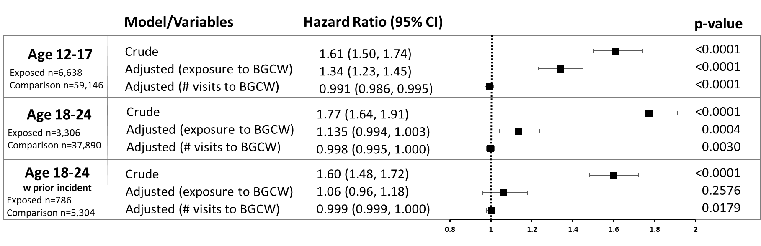

Health Outcomes

